Issue 2 – December 2019
Primary Care Networks This year the government have introduced Primary Care Networks into General Practice.
Wyvern Health Partnership has been confirmed that it can work as a Primary Care Network, which is great news as we are already a few years down the line towards working together. The government is changing how practices work and encouraging joint working and they are supporting this by funding additional roles within GP practices.

In 2019 – 20 they are fully funding a Social Prescriber and funding 70% of a Clinical Pharmacist role.

The rationale behind this is to encourage practices to work together and to enable different staff, other than a traditional GP or nurse, to see patients. Primary Care Networks should also help integrate primary care with secondary care (hospitals) and community care.

So what is a Social Prescriber?
The social prescriber role is not totally new to Swindon. Swindon Borough Councils’ Live Well team have provided Community Navigators within Swindon GP practices for a number of years. This role is very much about supporting patients who may need more than a traditional GP can provide.

They offer 1:1 support, within the practice or external to the practice to help a patient who may need help with the more social elements of their live, which is often impacting on their health. This could include help with diet, exercise, finances, care packages and isolation usually they will enable patients to link with community groups, befrienders and local people to continue to support them.

The Social Prescriber role is an extension of the Community Navigator and Wyvern has commissioned Swindon Borough Council to provide this service as they already do so much work in this area.

This will mean that we will have a full time member of the team who will support all 6 practices with additional time for the more social elements of their lives which in turn should impact positively on their health.

So what is a Clinical Pharmacist?
Again many of you will have seen Clinical Pharmacists within your own practices. The role is there to support GPs and they undertake a number of things including:
- Seeing patients for medication reviews
- Seeing patients in specific clinics such as diabetes
- Aligning medication when a patient is discharged from hospital to ensure that the medication is ready for the patient to request when they need it.
- Supporting GPs with their extensive pharmaceutical knowledge.

So where are with our recruitment?
Currently the Council is recruiting for the Social Prescriber role. We have interviewed for the Clinical Pharmacist role but have not been successful with this so this is going to be re-advertised.
What happens in future years?
The funding we get will continue next year for these roles and we will also be able to recruit to additional roles such as physiotherapists, physicians’ associates and paramedics. Wyvern’s Primary Care Network will also be looking at health data across our area to assess the needs of our patients and look at more targeted, proactive support.
The future will be very much about understanding our patients’ needs and providing more personal services to support them.
What is going on at Old Town Surgery?
Staff at Old Town Surgery
Dr Katherine Oldridge will be returning from maternity leave on 22nd January 2020. Susan Braddock joined our reception /admin staff in November, we welcome her to the team.
Patient Education Events
‘Bums, Boobs & Balls!’ – Let’s talk about cancer
In conjunction with the Old Town Surgery Patient Participation Group (PPG) the Surgery held a Cancer Awareness Event at Nationwide conference centre on 5th November 2020.
Guest speakers were Dr Anushka Chaudhry Consultant Breast Surgeon, Dr Rupert Beck Consultant Urologist, Hannah Hollis Cancer screening co-ordinator from Cancer Research UK, and Lisa Curtis Clinical Nurse at the Prospect Hospice.
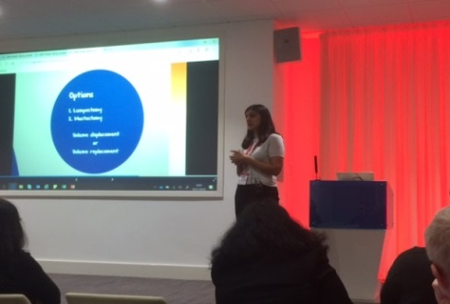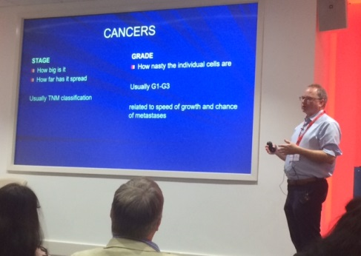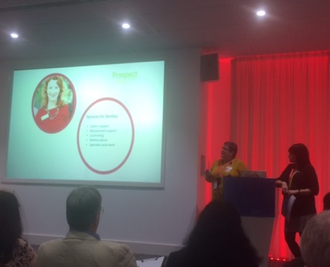
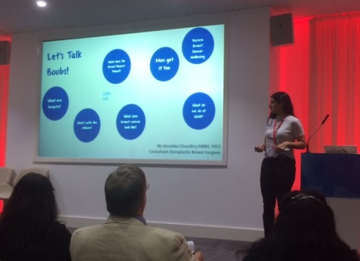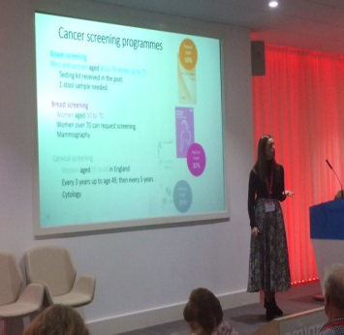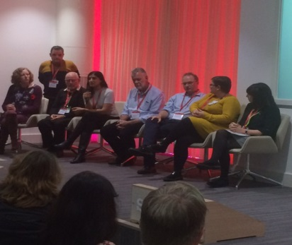

There were also representatives from Action Before Cancer (ABC) the Prospect Hospice, Cancer Research UK, Nationwide Building Society working carers network and Swindon Carers Centre.
The event was well attended but there was still space for more patients to attend.
Please see the Practice website for further information about our patient education events and how to register for future events at: https://www.oldtownsurgery.com

Patient Participation Group
The Patient Participation Group (PPG) meets once a month (usually on the 2nd Thursday of each month) Please see the Practice website for further information about finding out how to get involved in the PPG or just to find out about what we do.

